**Programming Proficiency – Final Project**

**Blackjack Game**

Thu Phuong HOANG

Nadine MENDIS

**1. Introduction**

This report contains an overview of how the Blackjack game was created. It begins by explaining how the program is compiled and executed through the command line. Following this, the main functionalities of the program are explained in detail along with all the relevant screenshots. The object-oriented principles and the advanced java techniques used in designing and developing this program have also been incorporated. Finally a conclusion and our reflections on making this program is provided.

# 2. Compilation

This Blackjack program has 4 classes: Card, Deck, Hand, and Blackjack (main driver class).

To compile this program, these steps should be made in order:

Step 1. Compile Card class: javac Card.java

Step 2. Compile Deck class: javac Deck.java

Step 3. Compile Hand class: javac Hand.java

Step 4. Compile Blackjack class: javac Blackjack.java

Step 5. Run Blackjack main driver class: java Blackjack.java

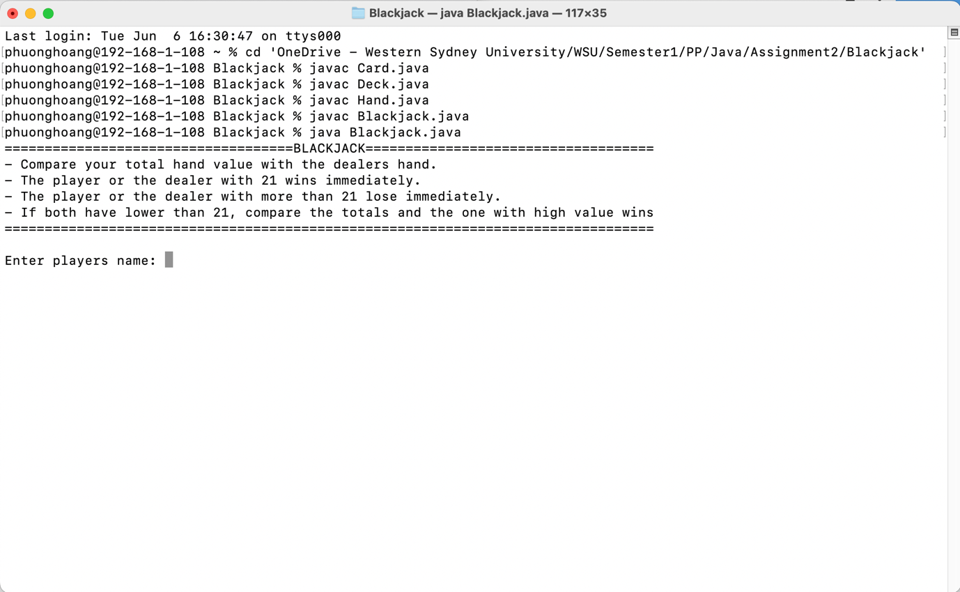

**Figure 1. How to compile**

# 3. Main Functionalities

- The user should see a brief introduction of the program and will be asked to enter his/her name to play the game.

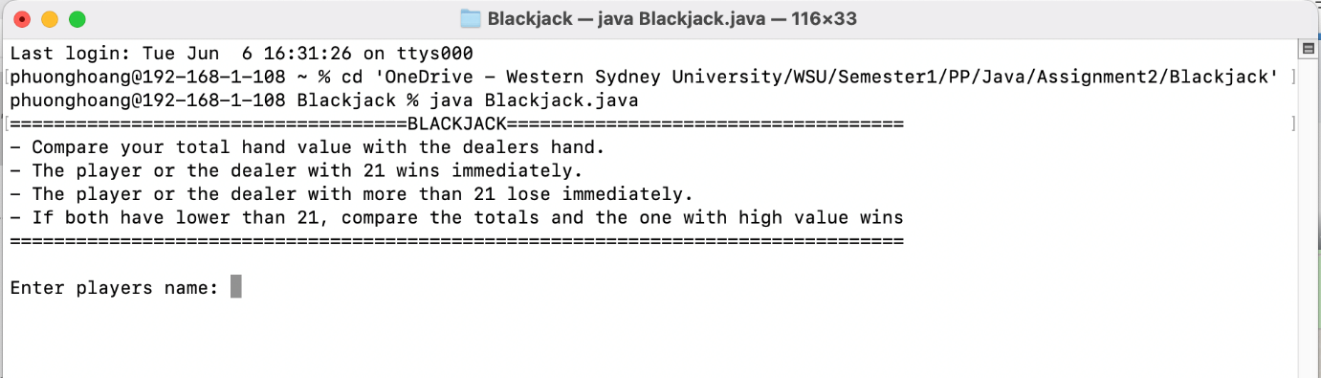

**Figure 2. Introduction display**

- After entering the name, a deck of 52 cards will be shuffled and showed on user screen. The user, now, should place their betting amount to continue playing.

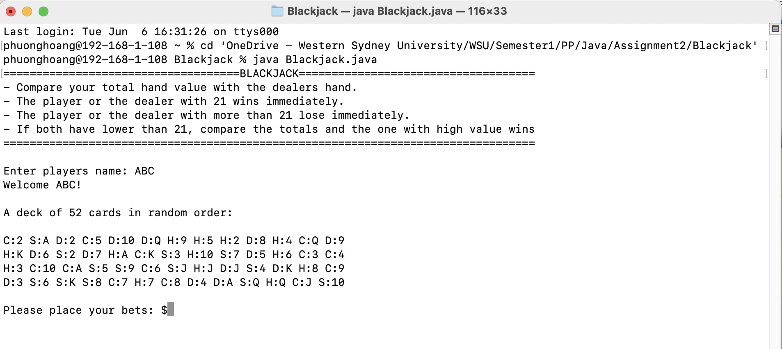

**Figure 3. Card shuffled display**

- The betting amount must be a positive numeric value which is greater than 0. If the player enters 0, a negative number, or any characters besides numeric number, the system will ask the player to enter the betting value again.

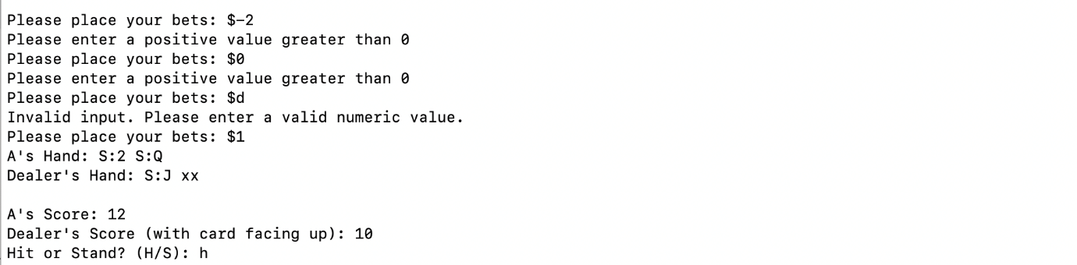

**Figure 4. Player needs to enter valid numeric value**

- After entering the betting amount, the player and the dealer will have 2 cards each. Both cards of the player are facing up, so the player hand amount (player’s score) should be known. While one card of the dealer will be facing up, another one is facing down. They can only know the dealer hand amount (dealer’s score) of only one card. Here, if the player score equals 21, the player wins immediately.

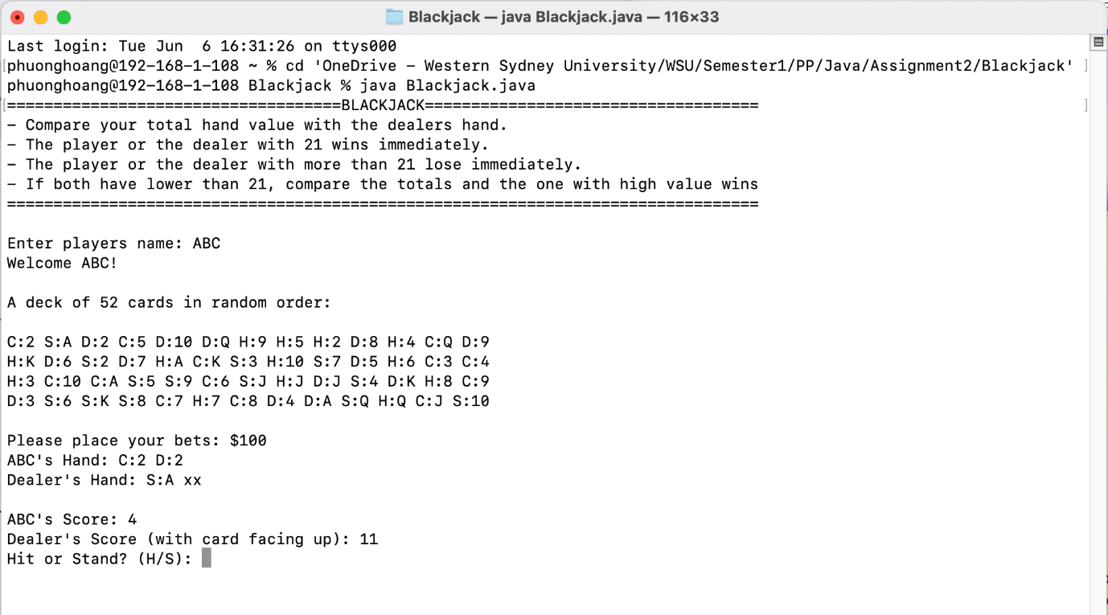

**Figure 5. Player and Dealer first 2 card and score display**

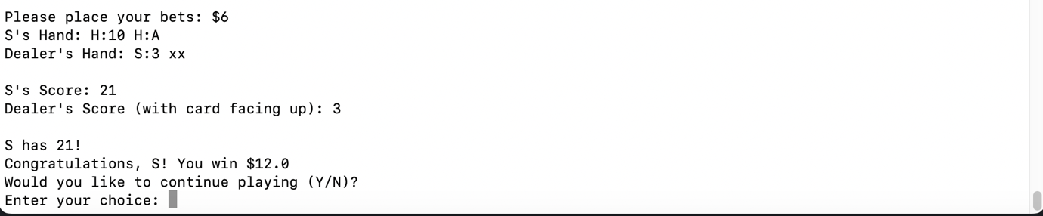

**Figure 6. Player wins immediately with first 2 cards if the player score is 21**

- If the player score is lower than 21, he/she should choose to hit or stand. If the player chooses “H” to hit, he/she will be given another card. The player hand and score will be displayed. If the player score equals 21, the player wins immediately. In contrast, if the player score exceeds 21, the player loses immediately. If the player score is lower than 21, he/she could choose to hit or stand again. This loop will continue until the player wins or loses or choose “S” to stand.

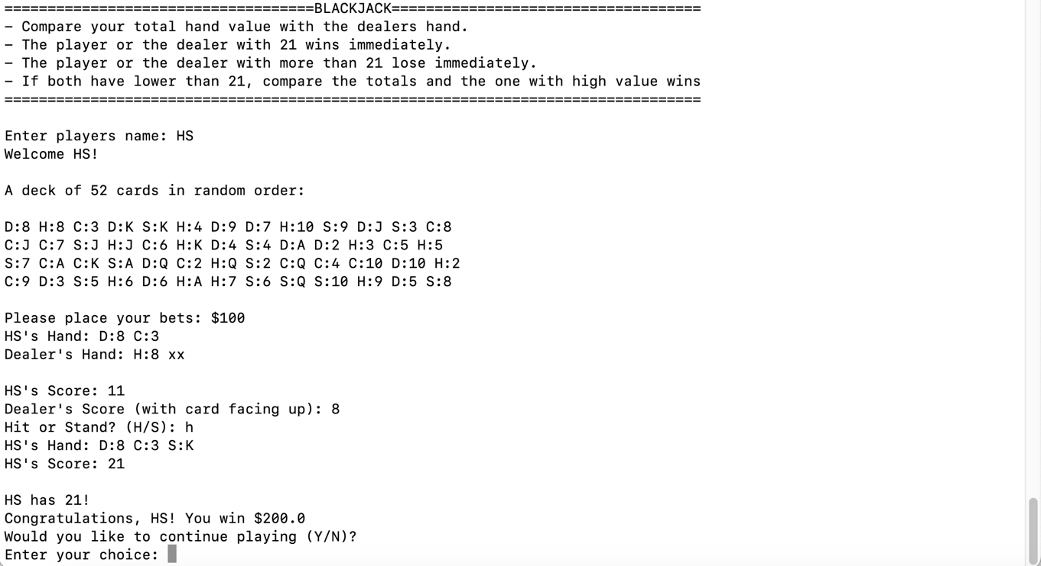

**Figure 7. The player wins immediately because the score is 21**

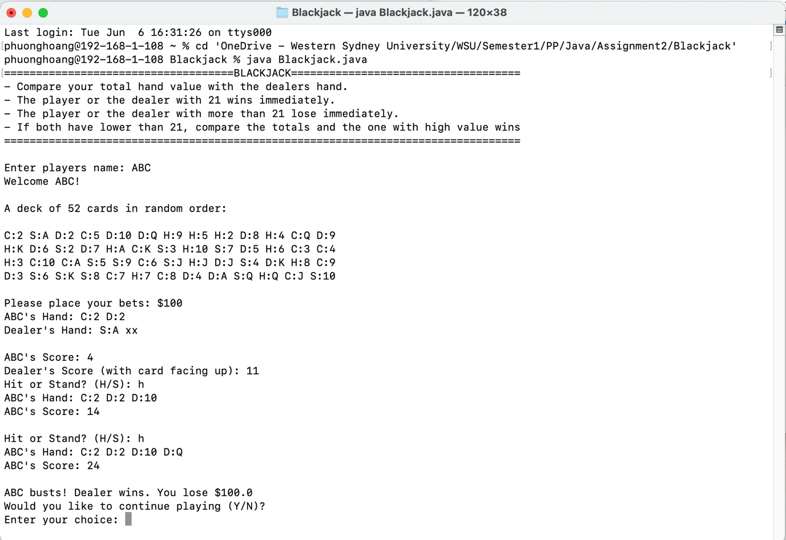

**Figure 8. The player loses immediately because the score exceeds 21**

- If the player chooses to stand, the facing down card of the dealer will be revealed. The dealer hand amount of 2 first cards will be shown. If the dealer score is 16 or lower, the dealer will get more cards until the dealer score is greater than 16. If the dealer score equals 21, the dealer wins immediately. In contrast, if the dealer score exceeds 21, the player wins.

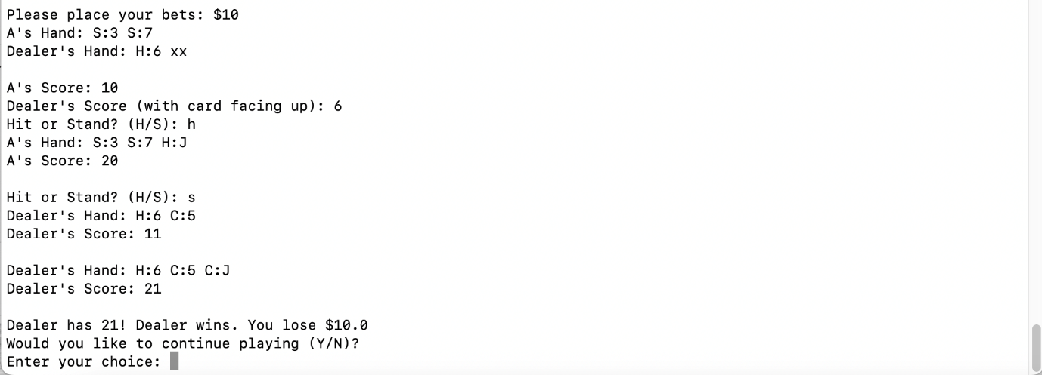

**Figure 9. Dealer wins immediately because the score is 21**

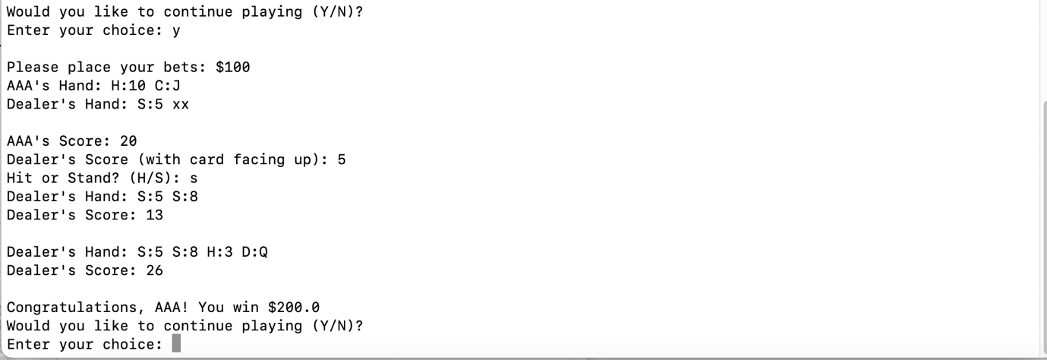

**Figure 10. Player wins because the Dealer score exceeds 21**

- If both player score and dealer score are lower than 21, the score of them will be shown to compare with each other. Whose score is higher will win the game. Or it’s a tie if the player and the dealer have the same score.

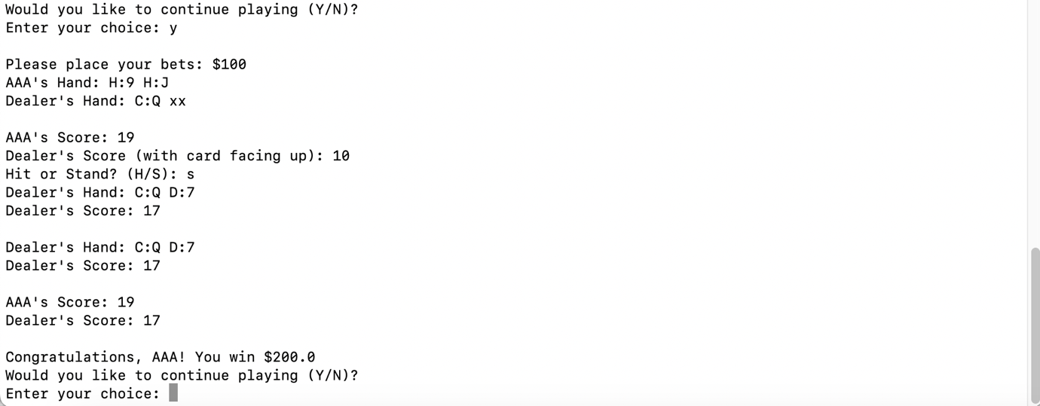

**Figure 11. Both score is lower than 21 and Player score is higher. Player wins.**

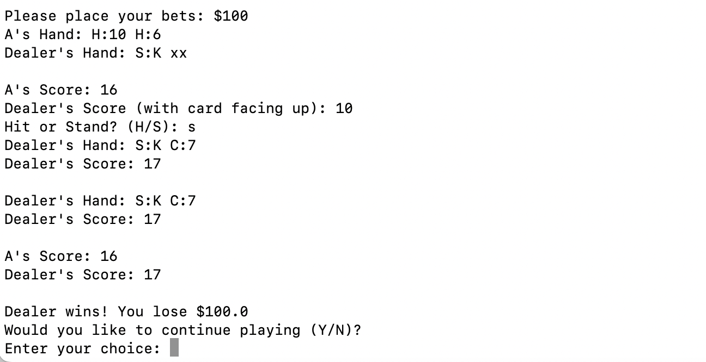

**Figure 12. Both score is lower than 21 and Dealer score is higher. Player loses.**

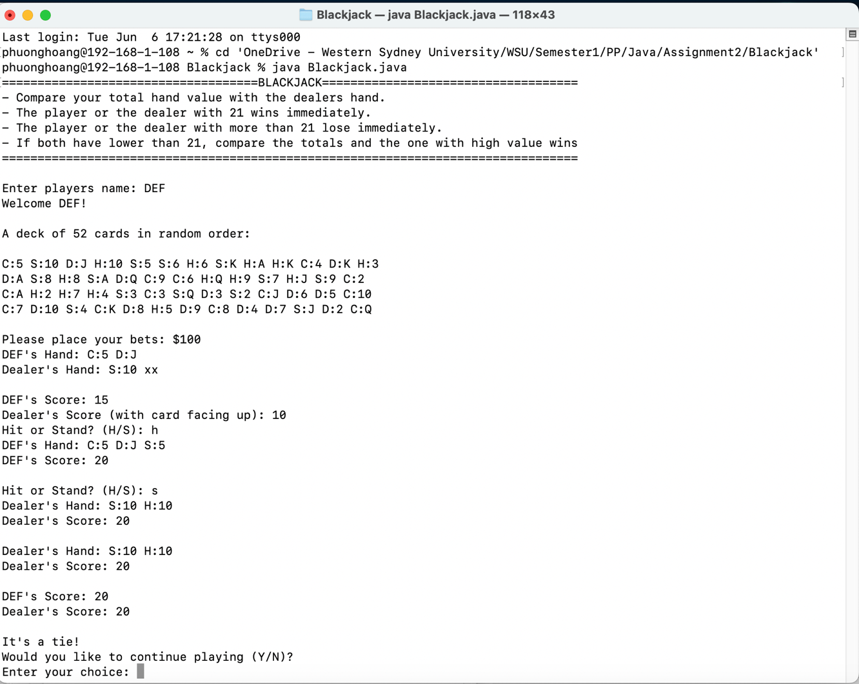

**Figure 13. Player score equals Dealer score. It’s a tie.**

- The Ace card value can be 1 or 11 based on the cards that the player and the dealer have. First, the Ace value is 11, but if that Ace card makes the value greater than 21, that Ace value will turn to be 1.

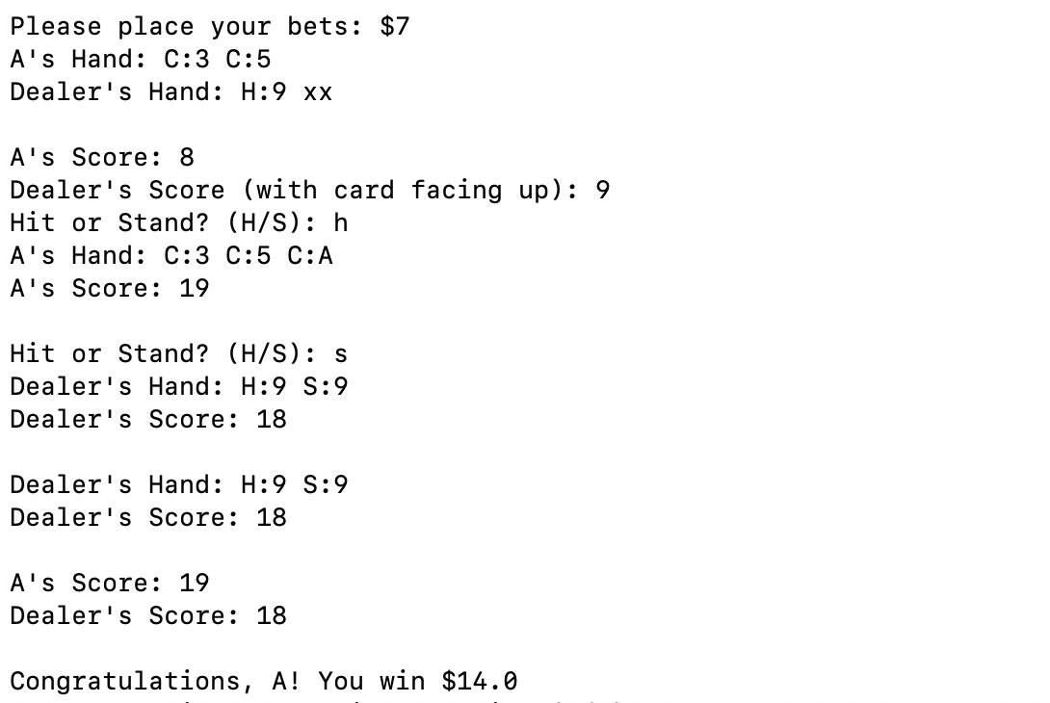

**Figure 14. The Ace value is 11 because the total value is lower than 21**

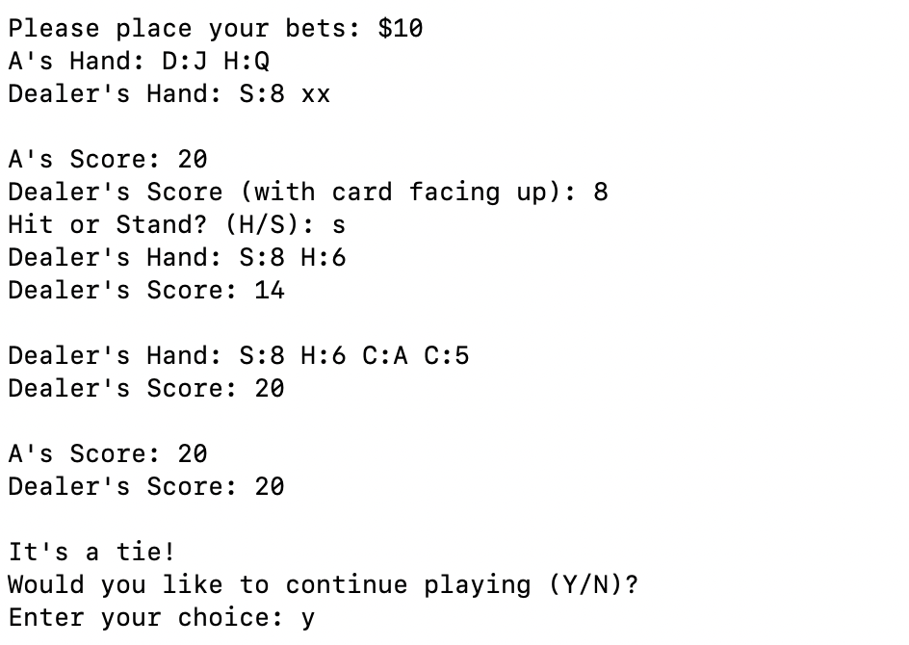

**Figure 15. The Ace value is 1, so the total value not over 21**

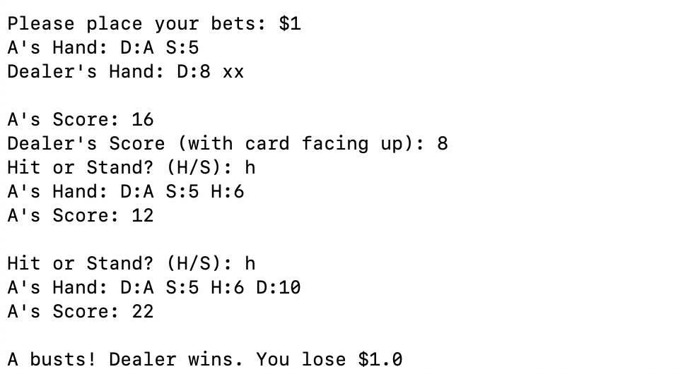

**Figure 16. At first, the Ace value is 11. Then, it turns into 1 to make the value not over 21.**

- Then, the player will be asked to choose to continue playing or stop. If they enter “Y”, the game will continue, or else it will stop.

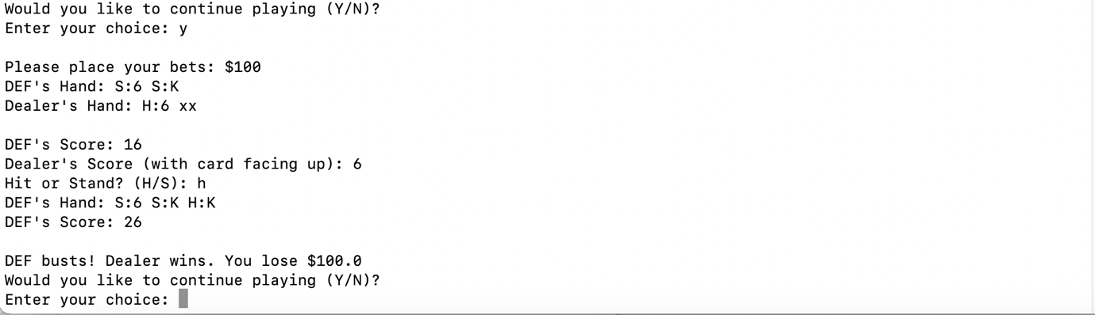

**Figure 17. Player continues playing**

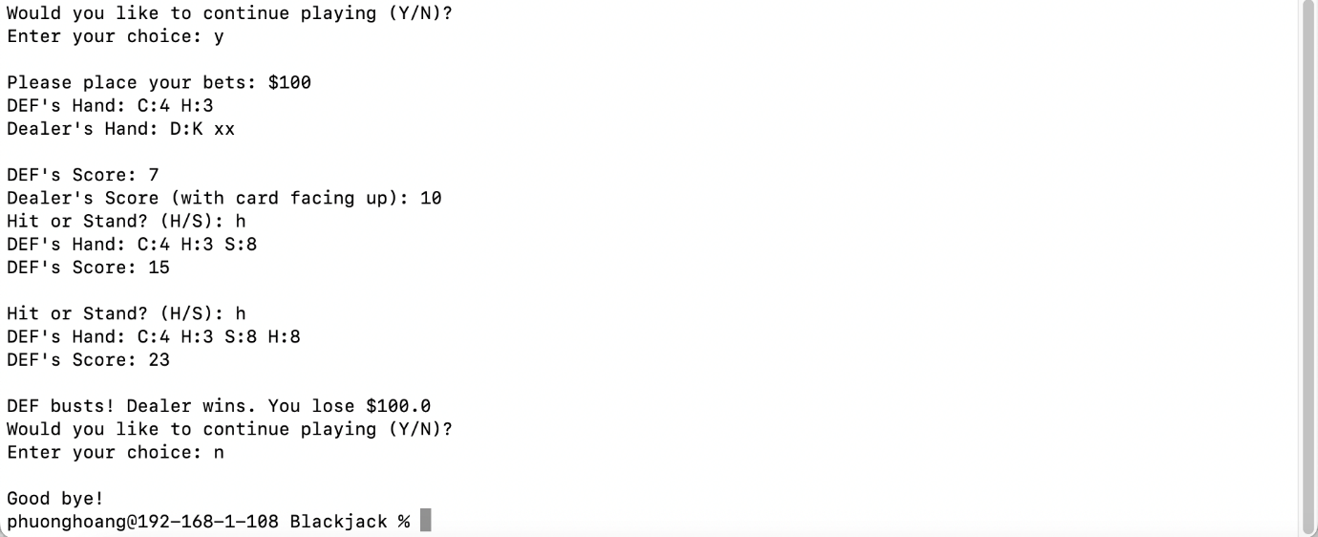

**Figure 18. Player stops playing**

# 4. User Interface

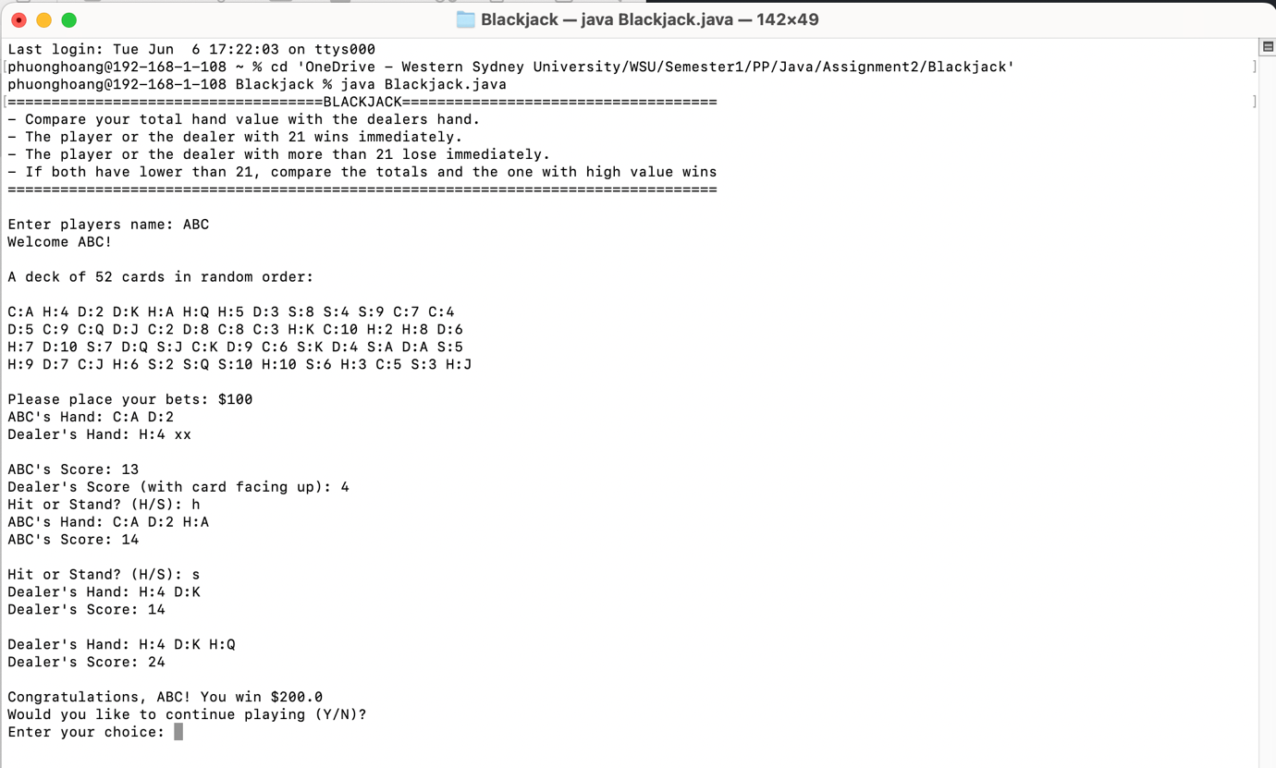

**Figure 19. User interface**

With the above interface, user can easily understand the main function of the game. The player will be guided to enter input step by step, with clear information.

# 5. Object-Oriented Programming

This Blackjack program has used several object-orientated concepts such as the use of classes and objects, encapsulation, and abstraction to ensure modularity and reusability of the code.

**Classes and Objects:** The program contains four main classes representing entities such as card, deck, hand, and the Blackjack game itself. Each of these classes have their own properties and behaviours. Throughout the program, objects of these classes have been created and utilized.

**Encapsulation:** The properties and behaviours unique to each entity are encapsulated in each class that has been created. For example, the class Card has properties such as suit and face. It also includes accessors such as getSuit() and getFace() for the driver class to access and manipulate. This promotes information hiding.

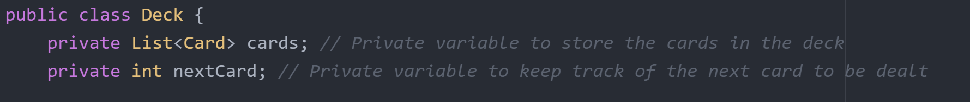

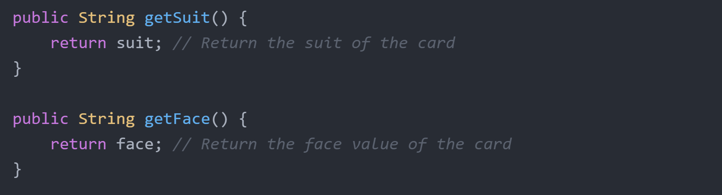

**6. Advanced Java Technical Aspects**

**Nested loops and if-else statements:** This program make use of multiple nested loops and if-else statements to execute each step of the game. There is an outer do while loop that executes the code within it while the user selects yes to continue playing the game. Inside this loop there is another do-while loop to make sure the user enters a number greater than 0 for the bet. There is a final while loop after that executes until the user wins, loses or has a tie with the dealer.

**Try-Catch statement:** A try catch statement was used to handle a situation in which a user enters characters or String instead of an integer when requested to place their bets. The try statement includes the code that needs to be tested for errors while the catch statement includes the code segment that is executed if an exception occurs.

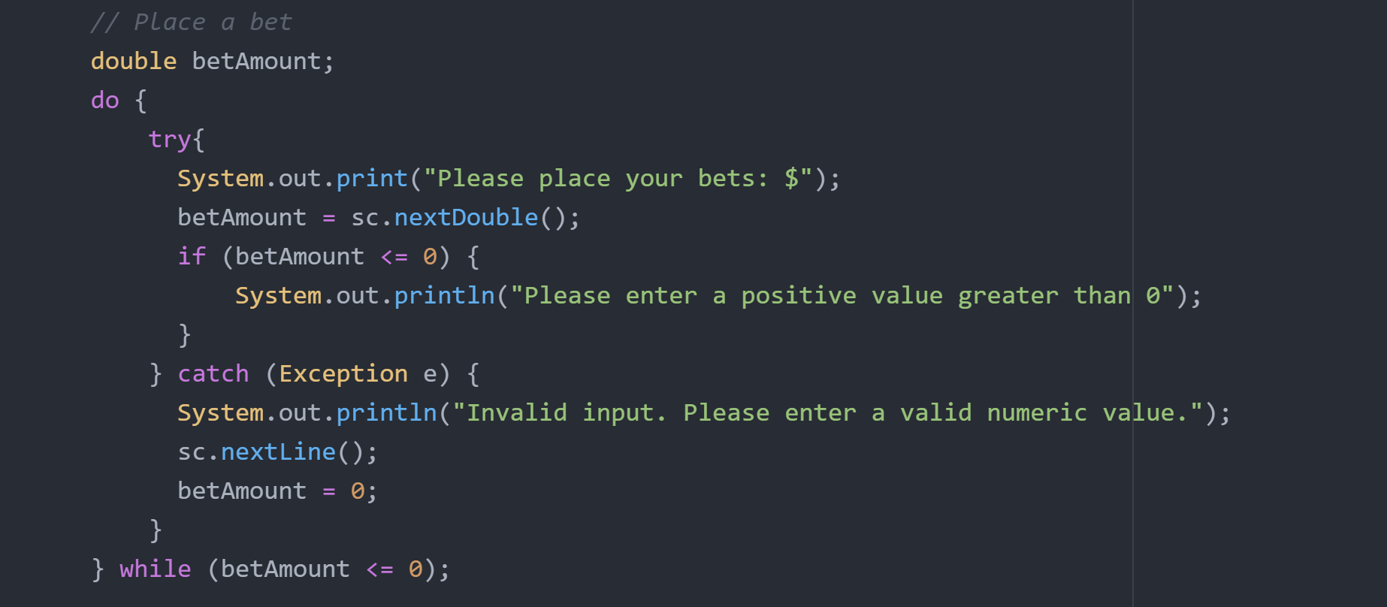

**Classes and objects:** This program uses object oriented concepts by separating the entities involved in the Blackjack game into multiple classes that have their own properties and behaviours.

# 7. Conclusion

This program simulates a Blackjack game with one deck of 52 cards, one player, and a dealer. It consists of four classes, which are Card, Deck, Hand, and Blackjack. The Card, Deck and Hand classes are support classes while the Blackjack class is the main driver class that executes the game. For the execution of the gameplay, a combination of nested loops and if-else statements were used for the different scenarios involved.